In the name of God

Digital Electronics
CA3
Mohammad Yahyapour

Part 1
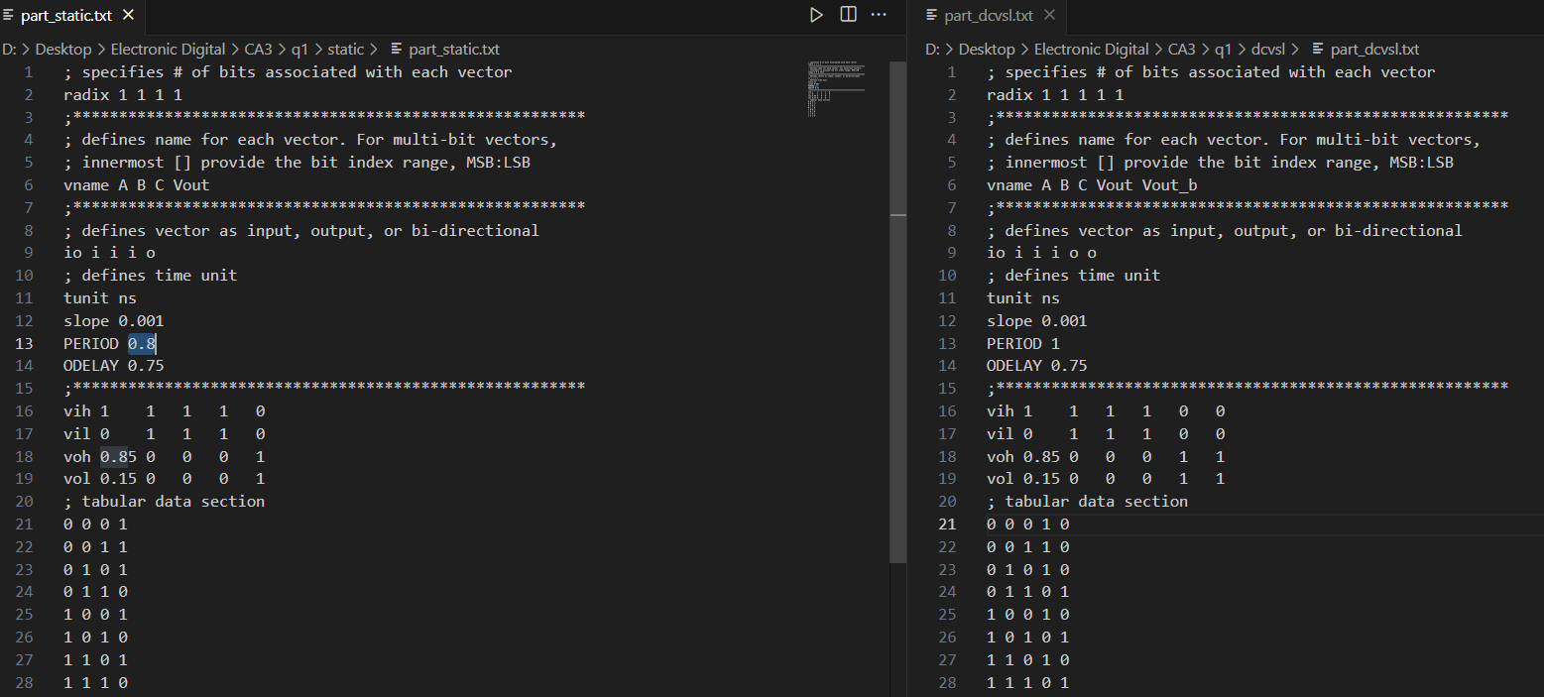
a) Using a vector, all 8 input states are applied to the circuit.

The number of transistors used in static CMOS is 6, whereas in DCVSL it is about 14 (including 6 transistors for inverting the inputs).
b) The case in which the maximum delay occurs has been selected, considering that all capacitors are either fully charged or discharged.Static:
$$t_{LH}=(0, 1, 1)→(0, 0, 1)$$
$$t_{HL}=(0, 0, 1)→(1, 0, 1)$$

DCVSL:
$$t_{LH}=(0, 1, 1)→(0, 0, 1)$$
$$t_{HL}=(0, 0, 1)→(1, 0, 1)$$
Inputs of both circuits are the same.
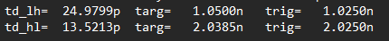
As shown in the two images above, the DCVSL delay is greater than that of static CMOS because a feedback circuit is used to ensure the output reaches a full swing. This causes the output to be ready with a longer delay.

c) The static power of the circuits is as follows, and as expected, the power consumption of DCVSL is roughly more than twice that of static CMOS, which approximately corresponds to the ratio of the number of transistors on both sides.
static:

DCVSL:

d) Similar to static power, dynamic power also has a direct relationship with the number of transistors on each side, and the dynamic power of DCVSL is more than twice that of static

CMOS.Static:

DCVSL:

Note: The vector file part_dcvsl.txt was used only to provide inputs for section a, while for the other sections, the vector file part_dcvsl_b.txt was used, which provides the same inputs for both circuits.

Part 2
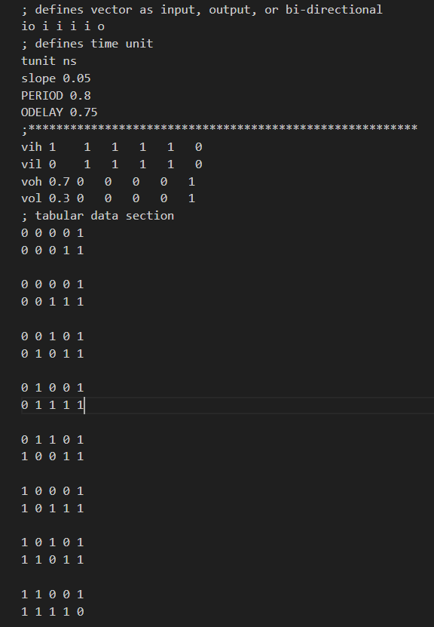
a) Using a vector, all 8 test cases have been applied.

b) During the precharge phase, the input $(1,1,1)$is applied so that all PDN capacitors are charged, and finally, all these capacitors are discharged during the evaluation phase.

c) Simultaneously, while checking all 8 states to verify the correctness of the circuit, the power consumption during that period was also measured, as shown below.
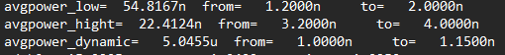

Note: The file part_NAND.txt was used to provide inputs only for sections a, b, and c.

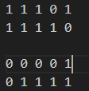
d) The inputs were applied as shown in the figure, using the file part_NAND_d.txt for this section.
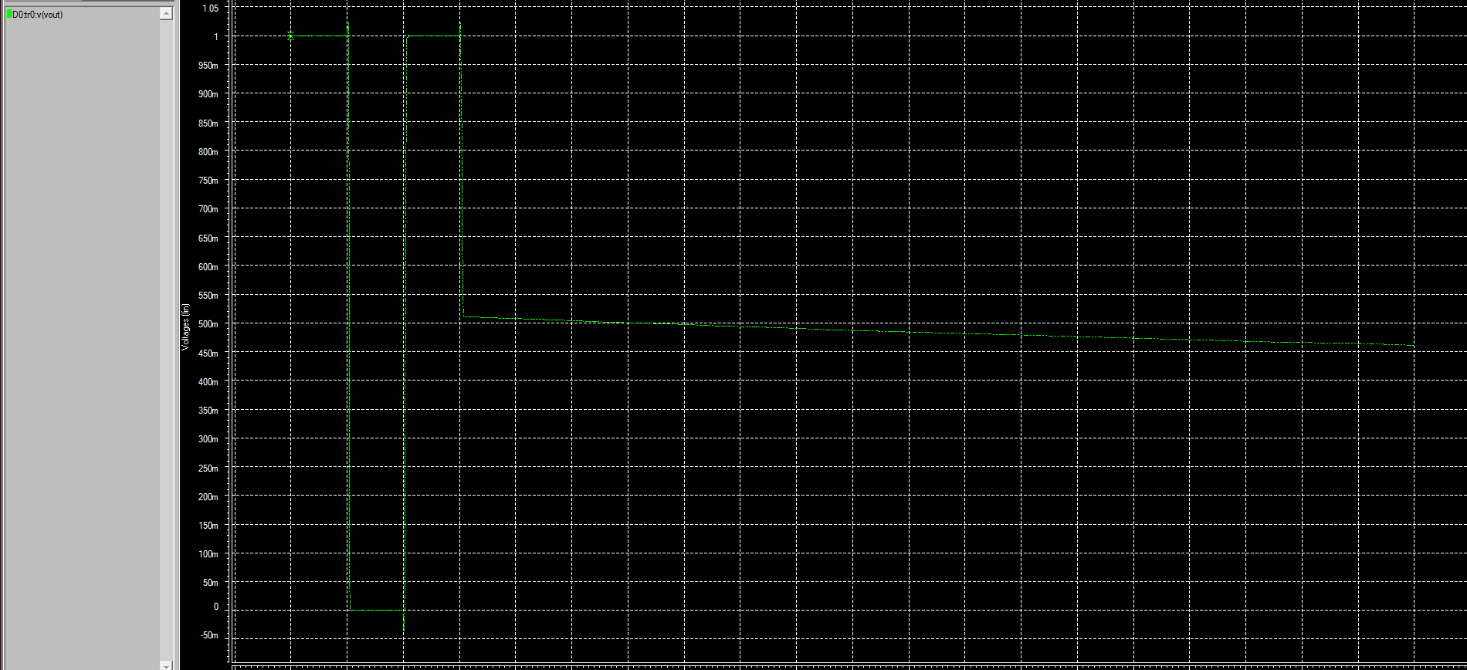
As shown in the figure above, the output logic should have been 1, but due to the charge sharing phenomenon, the output is closer to 0 than to 1. The input selection is done as follows: first, with an output of 0, all capacitors are discharged; then, during the charge sharing phase, we prevent the capacitors between inputs C and B as well as A and B from charging with the next input. In the evaluation phase, when the output is not connected to anything, C is connected to charge the PDN capacitors.

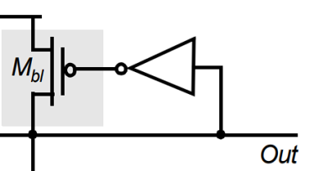
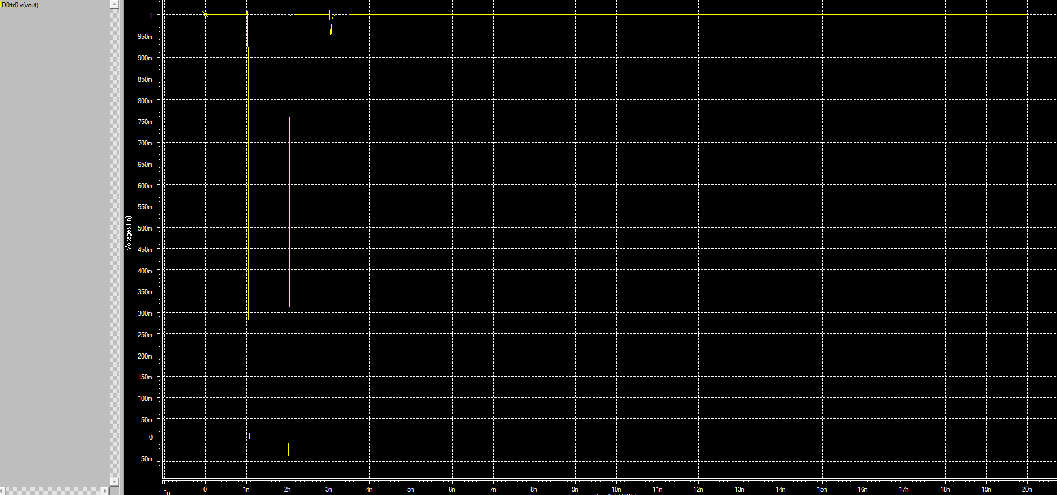
e) As shown in the figure below, by adding a NOT gate whose input comes from the output and whose output is connected to the gate of a PMOS, the circuit can produce precise 0 and 1 output levels. The issue with this structure is that it is ratioed—the PDN must have enough strength to pull the output to 0 and turn off the PMOS.

Note: Sections d and e were driven using the vector file part_NAND_d.txt.
Note: In this section, due to voltage drop at the output, values above 0.7 V are considered as logic 1, which has also been applied in the vector file.

